Name
Date of Birth
Mobile No
Asthma Review – 14y and over
We follow best practice and ask patients with asthma to review their asthma every year. It is best to book an appointment with our Asthma Nurse Specialist to review your asthma. An alternative is to complete this form and return the form to reception at your surgery. A clinician will contact you if we need to discuss your asthma further. Thank you.
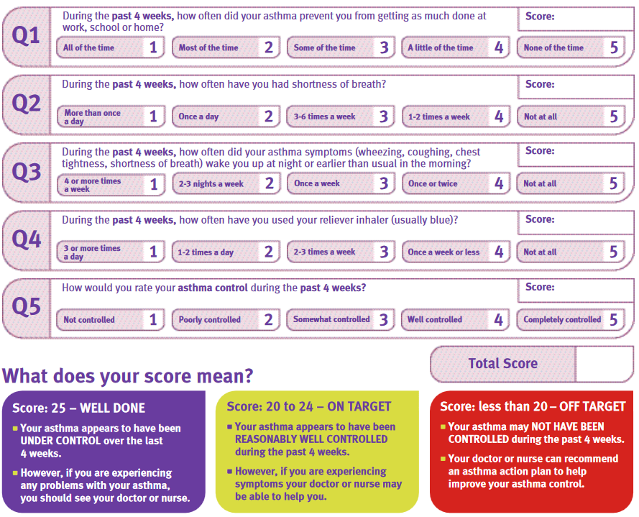

Do you smoke? Smoking worsens asthma
Never smoked □ I still smoke □ Consider stopping!
Used to. I’ve stopped □ I want help to quit □ www.nhs.uk/smokefree

We recommend this useful website to find out more about managing your asthma:
www.asthma.org.uk/advice/manage-your-asthma/adult-review

