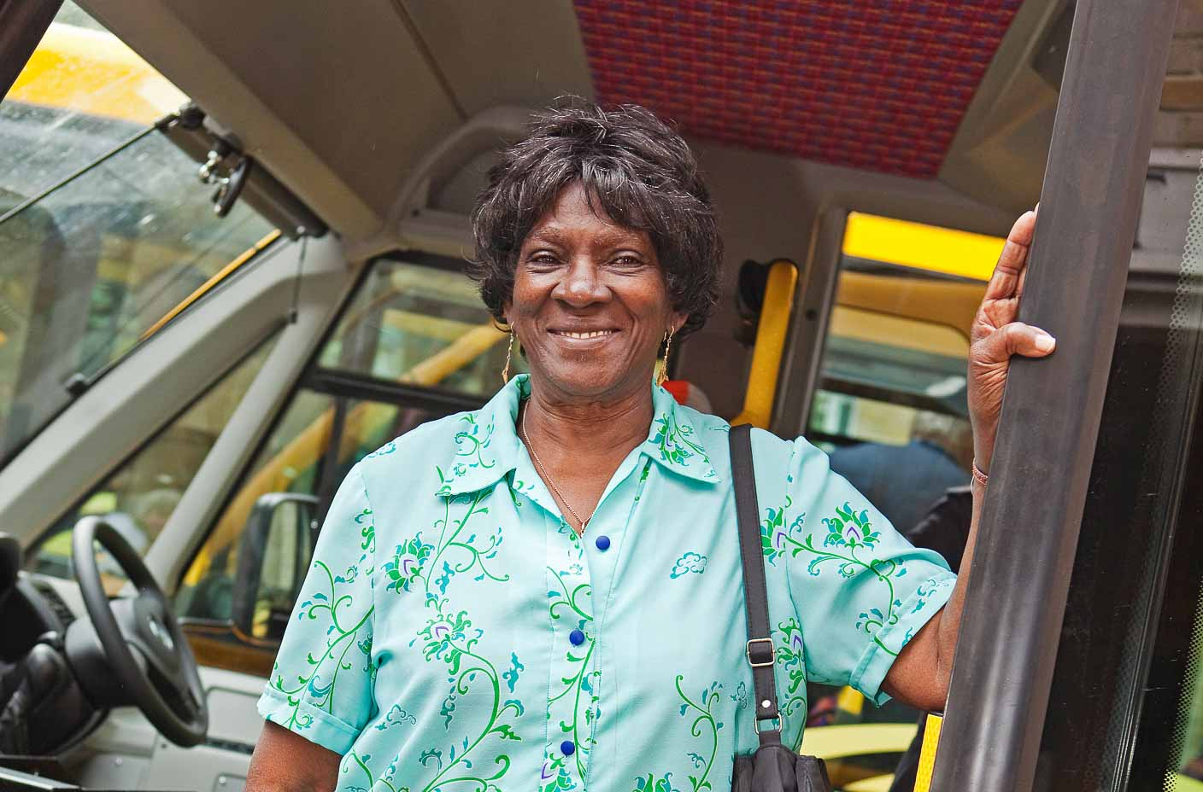
Dial-a-Ride

Our daily demand responsive, door to door transport service is available to residents of Bristol who are unable to access conventional public transport and operates from Monday to Friday, 9am to 5pm.

Bus Fares
Fares are charged at a similar rate to conventional public bus services and you can travel free of charge with a Bristol City Council Travelcard (bus pass) just as you would on a conventional bus service - just show your pass to the Driver on each journey.

Where can I go?
Our service users regularly request transport to the following popular destinations:
Broadmead and the city centre, local shopping locations, hair salons, local health centres & GP surgeries, local hospitals, community centres, social and leisure facilities, places of worship

When can I travel?
You decide where you want to go, on what day and when. If we can't provide transport to your exact needs, we will discuss alternatives with you to support you with your travel plans.
Our Dial-a-Ride service is very popular and we reserve the right to make best use of the vehicle fleet to allow as many service users to travel as possible.

Membership
To join the Dial-a-Ride Service, you will need to complete a simple application form and pay the annual membership fee.
You can contact us on 0845 130 1875 or email us bctoffice@hctgroup.org to request an application pack (office hours 09:00 to 16:00 Monday to Friday).

