**GP Care DVT Service Guide: Making a Managed Referral**

Record your consultation by launching the template ‘DVT Risk Assessment (BNSSG) ‘

Save the consultation then open it again so the information is recorded in the EMIS database

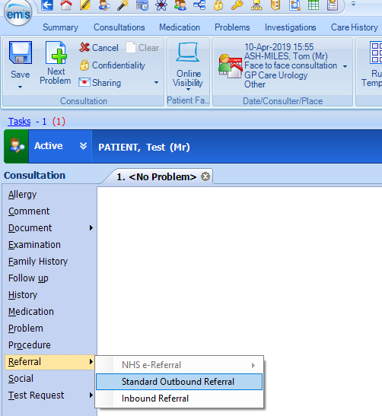

From Consultation

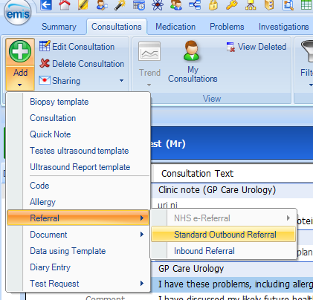

From Record

Click on the referral tab

1. Add a Standard Outbound Referral from the patient record, either in record view or consultation.

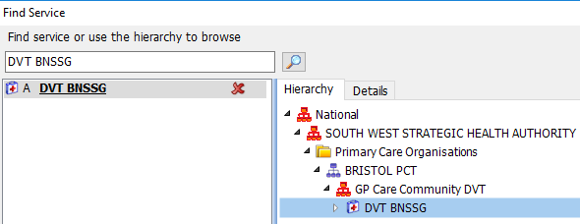

Where the referral is going. The first time you make a referral, you will need to search for DVT BNSSG as shown below. Subsequent referrals should have DVT BNSSG in the Referral Target drop-down menu.

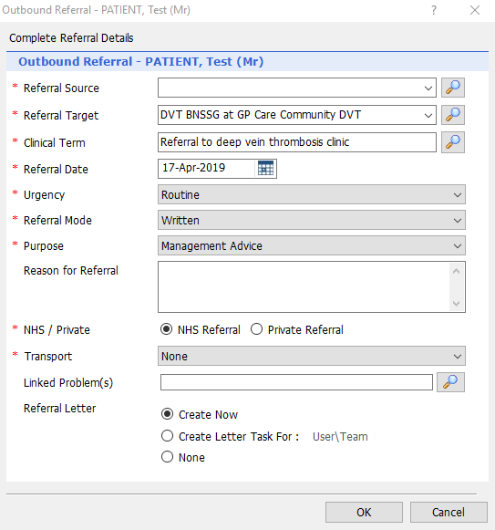

YOUR PRACTICE HERE

The Clinical Term will be coded in the patient’s Referrals tab.

**Please always create a letter for the referral.** You have been sent the BNSSG DVT referral letter document template for this purpose. If you Create Letter Task for a secretary team, they will need to perform Save & Send (Step 4).

These fields can be left on their default settings. We understand that all DVT referrals have a degree of urgency.



1. Complete the Referral Details. Many of these will auto-populate.

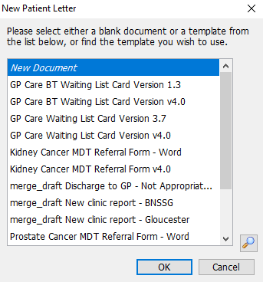

1. When you press OK, you’ll be asked to create the referral letter. Please search for the provided document template - OC Referral to DVT Service (BNSSG) (GP Care) by typing “dvt service”

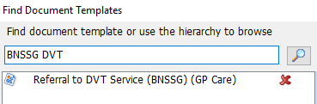

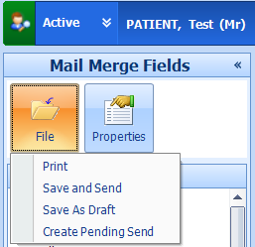

1. Complete the referral letter, then go to **File > Save & Send.**

*If the Save & Send option is not visible, you may need your local EMIS Administrator to add the RBAC “B8016” to your EMIS profile (to add this to your smartcard, please contact your CSU Smartcard Team).*

The referral and accompanying letter have now been sent to GP Care’s DVT service. You can check the status of the referral following the instructions on the following pages.

Checking a Managed Referral has been sent

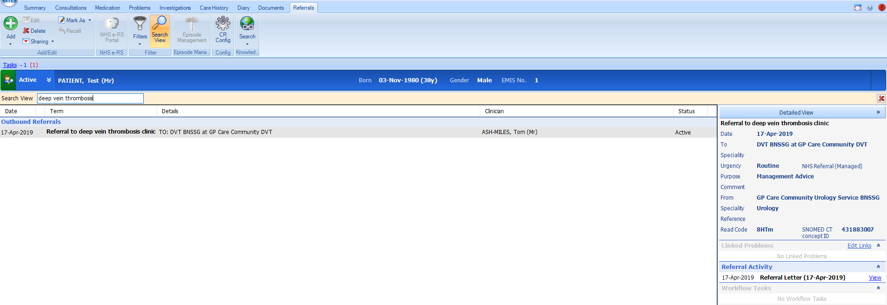

1. Referral details can be found on an individual patient’s record by going to Care Record > Referrals.

Details are displayed to the right of the screen.



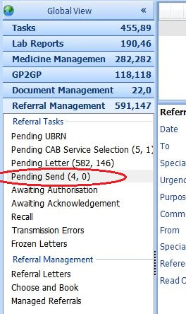

1. If you previously chose the “Create Letter Task For:” option when making the referral, or want to check for any unsent referrals, you can do so by checking the Referral Management section of Workflow.

Any letters in the **Pending Send** inbox require the “Save & Send” option to be selected, **as they have not yet been sent to GP Care.**